Manual for the 3D annotation program.

1. Start the program and make annotations
To start the program type ‘StartImageAnalysis’ on the command line.

The following GUI will appear: stackBrowserControl Main GUI.
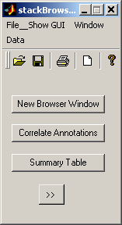 Figure 1

The StackBrowser Main GUI
- New Browser Window on the stackBrowserControl Main GUI will call a StackBrowser Main GUI in which a ‘tif’ file can be loaded.
- To load a stack of images (tif format), locate and open the file using the Browse button
- A new StackBrowser Main GUI (this will be named s2_StackBrowser Main GUI) can be called as before. A second stack of images can be loaded into this window, e.g. from a subsequent or earlier imaging day. By default the images are median filterered (see fig. 13).
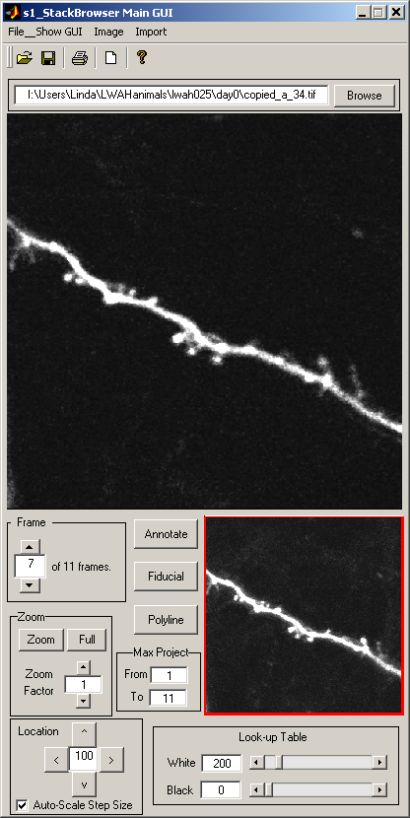 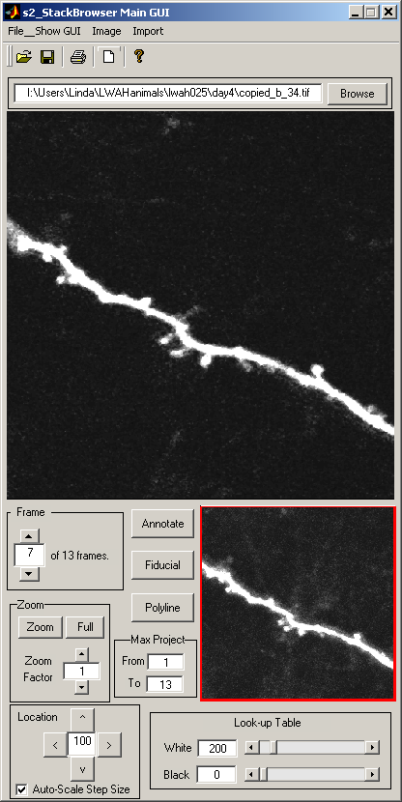 Figure 2
Funtions on the StackBrowser Main GUI
- The upper window (also called Primary) displays one frame of the image stack at a time. The user can switch to other frames using the arrows at the Frame box, by changing the number in the box, or by using ‘hot’ keys on the keyboard – by default these are the z and the x keys. First perform a left mouse click in the window to acitvate the ‘hot’ keys.
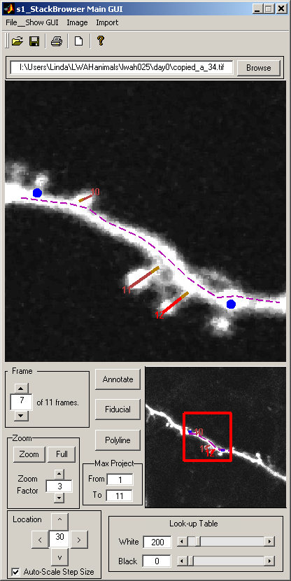Figure 3
- The lower window (also called Global) displays a max-projection of the image stack. By default the whole stack is used. The user can change the frames used for the max-projection in the Max Project boxes.
- The user can change the zoom on the primary window by using the arrow buttons at the Zoom box, or by typing the zoom factor into the box, or by using the Zoom and Full buttons. After selecting the the Zoom button the cursor transforms into a cross-hair, which allows the user to select an ROI on the primary window to which to zoom in (by default the ROI has to be selected on the primary {see fig. 17 for how to change this}). The Full button will recover the Full view. The ROI will be indicated by a red box on the global.
- The location of the ROI can be changed using the arrows at the Location box, or by using hot- keys on the keyboard – by default these are the s (left), e (up), d (down) and f (right) keys, and/or the arrow keys on the keyboard. The number in this box indicates the step size (in pixels) of this movement. The step size automatically changes according to the zoom factor (Auto_Scale Step Size box is checked by default). The step size can be manually modified in the box and by unchecking the Auto_Scale Step Size box.
- The location of the ROI can also be changed by dragging the red box with the mouse.
- The brightness of the image (in both the primary and the global) can be changed using the arrow button in the Look-up Table. The numbers can also be changed manually. White indicates the lowest pixel value that will be displayed as 100% white, Black indicates the highest pixel value that will be displayed as 100% black. Use this box regularly to change intensities needed to enhance dim structures or to reduce disturbing haze from bright structures when making annotations.

Fiducial points
Fiducial points are useful for alignment and registration of image stacks in different StackBrowser Main GUI windows. A fiducial point can be set using the Fiducial button, or by a right mouse click on the primary followed by selecting Fiducial in the roll-down menu. The cursor will transform into a cross-hair that allows selection of a point on the primary. A left mouse click will set the point (displayed as an asterisk), a subsequent right mouse click or Enter (on the keyboard) will store the coordinates and display the point as a red (blue when unselected) dot. It has a unique ID and is indicated as point # in the annotationWindow (see below). Fiducial points can later be correlated across image stacks using the Correlate Annotations function (called on the stackBrowser Control Main GUI, see fig. 7 and 8).

Polylines
Polylines can be used to annotate and measure the length of large structures, e.g. to trace a dendrite or an axon. A polyline can be created using the Polyline button. The cursor will transform into a cross-hair that allows to select points on the primary. A left mouse click will set a point to which the line (straight) will be extended. A right mouse click will set the end point of the polyline and bring the user back to the cursor. The polyline is displayed as a dashed line, it has a unique ID and is indicated as polyline # in the annotationWindow (see fig. 5). The user can select points across frames, by moving up and down using the Frame up and down arrows while in the middle of drawing a polyline. One can extend an existing polyline by a right-mouse click on the line and selecting Extend in the roll-down menu.

Annotations
Annoations can be used to indicate small structures (that can be connected solely by a straight line through two points). Use the Annotate button, or the hot-key a on the keyboard to start the annotation, or by a right mouse click on the primary followed by selecting Annotate in the roll-down menu. The cursor will transform into a crosshair, left mouse click on the starting point, right mouse click on the end point. The annotation will be displayed as a red (or brown when unselected) line, accompanied by the ID number. Unlike polylines annotations can not run across different frames.

Right mouse click functions on the primary
A right mouse click on the primary will call a small menu with the following options:
- Annotate to start an annotation.
- Fiducial to set a fiducial point.
- Zoom to select a ROI (also present as right mouse click function on global). The default is to select the ROI on the primary (see below to change this to global).
- Zoom in to automatically zoom in (also present as right mouse click function on global).
- Zoom out to automatically zoom out (also present as right mouse click function on global).
- Copy to copy the current ROI (also present as right mouse click function on global). Used to paste the image (by default in EMF format, including the filename and the annotations, see fig. 17) into another program (e.g. Excel, Word, Powerpoint etc.).

The toolbar on the StackBrowser Main GUI
Figure 4
- Show GUI, to bring up the annotationWindow GUI, the stackBrowserUnits GUI, and the Photometry GUI (see fig. 5, 6 and 20.
- Image, to load an image stack, to chose the filter type, and to unregister an image stack (to undo registration executed by the the Register By Fiducial Points function, see below).
- Import, to import neurolucida branches.
The annotationWindow.
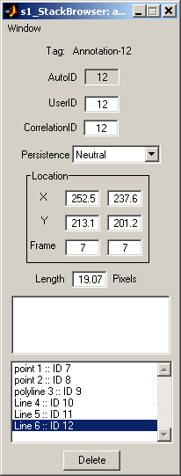 Figure 5
- Tag indicates which annotations is selected.
- AutoID is the ID number that is automatically set and stored by the program (can’t be changed).
- The UserID is the ID number that the user wants to give to an annotation (e.g. for selection or grouping purposes during data analysis, UserIDs are not necessarily unique).
- CorrelationID is the number displayed on the primary and global, and will change upon use of the correlation function (see below).
- Persistence indicates the status of an annotation, to indicate e.g. whether the annotation is new or stable (or lost or transient) across image stacks. By default this is Neutral (the line on the primary is brown). It can be manually changed to Stable (green), Loss (light blue), Gain (pink) or Transient (dark blue) in the roll-down menu. It will automatically change, together with the line colors, upon use of the correlation function (see fig. 9).
- Location X, Y, Frame indicates the coordinates of the start point and end point of an annotation as well as the frame in which the annotation was made.
- Length indicates the length of the annotation. By default in Pixels, unless otherwise indicated in the StackBrowser Units GUI.
- Below Length is a white space to write down notes.
- Below the white space is a list of all annotations. The currently selected annotation is highlighted.
- Delete button, to delete an annotation.

The StackBrowser Units GUI:
- Fill out the conversion factors in the StackBrowser Units GUI and check the Enable unitary conversions box. By default this box is automatically updated with the last values that were used in the previous stackBrowser Main GUI.
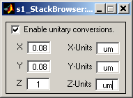 Figure 6
2. Correlate annotations across different image stacks
- Use the Correlate Annotations button on the stackBrowserControl Main GUI to call the AnnotationCorrelator Main GUI.
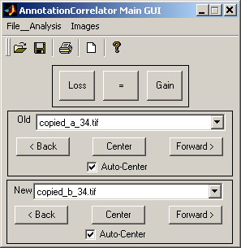 Figure 7

The functions on the AnnotationCorrelator Main GUI
The correlator has two operation modes: i) Manual. The user manually selects an annotation in two image stacks and correlates them. ii) Semi-automated. The program takes the user through each of all annotations in both image stacks; the user manually correlates them using the Loss, = and Gain buttons. The semi-automated correlator is called in the toolbar under Analysis, → Start Correlation. The manual mode can be used directly at any time.
- The filename in the Old box indicates the image stack to which the annotations will be correlated. The filename in the New box indicates the annotations that will be correlated (and thus change their correlation Ids). The pull-down menu allows selection of different filenames of image stack that are currently open in a StackBrowser Main GUI. When a new StackBrowser Main GUI is opened the ‘Old’ and ‘New’ will automatically change to the before-last and last image stacks respectively.
- Auto-Center. If box is checked the ROIs will shift to center the annotation in the primary (important for automated correlations, see below).
- Back, Center and Forward are used to jump back and forth in the automatic correlator, and to center the annotation.
- Loss, =, and Gain are used to indicate an annotation is lost, gained or maintained.

The menu bar on the AnnotationCorrelator Main GUI
Figure 8
- Use Analysis, → Start Correlation, to start the semi-automated correlation program. Two annotations will be highlighted: the nearest annotation in the ‘Old’ window and the annotation in the ‘New’ window of which the coordinates match that of the highlighted ‘Old’ annotation. The user can use the Loss, =, or Gain button to decide whether the ‘Old’ annotation is lost or maintained, or whether the ‘New’ annotation is gained. After all spines in both windows have been highlighted a small window will pop up indicating Correlation complete. Press OK.
- Use Analysis, → Stop Correlation to terminate the semi-automated correlator.
- Use Analysis, → Pause Correlation to temporarily leave the semi-automated correlator, e.g. if an annotation needs to be added or modified, and Resume Correlation to continue the process.
- Images, → Correlate Fiducial points will essentially execute the same procedure as the semi-automated annotation correlator. It will select fiducial points instead of regular annotations. Use the Loss, =, or Gain button to correlate fiducial points.
- Images, → Register By Fiducial Points will execute an spatial image transformation procedure, using the correlated fiducial points as reference points. The ‘New’ image will be registered according the standard ‘linear conformal’ transformation procedure in MATLAB (only translation, rotation and/or scaling; no shape changes).
- Images, → Register By Cross Correlation IS NOT yet OPERATIONAL.

Appearance of correlations
After annotations have been correlated their appearance in the window will change. Initially, annotations will be dark brown and have a light brown base. After correlation the color will change to either green (if it persists), light blue (if it is lost) or pink (if it is gained). If annotations in a third image stack are correlated as well, in the middle stackbrowser the status of pink annotations can change to dark blue (indicating that it was transient) and the green ones to light blue (in case they would be lost). If in a correlation session an annotation has been skipped, the base of annotation will remain brown (even if the annotation itself has changed color, e.g. due to correlation to a previous image stack). This facilates the user to find non-assigned annotations (e.g. in the lower example this is annotation 26 in the middle stack browser).
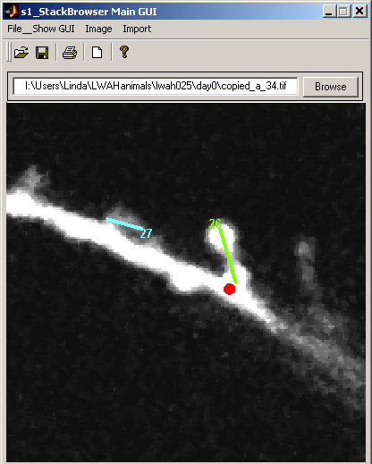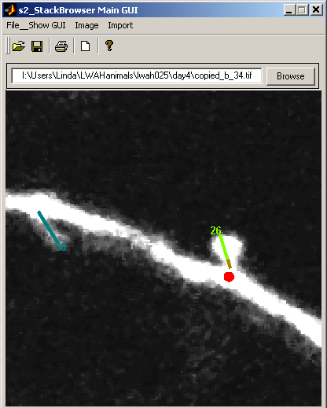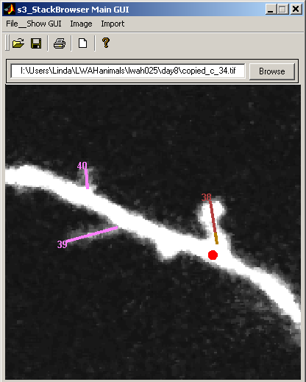
Figure 9

3. Saving, loading and viewing data sets.
Saving and loading data is done using the roll-down menu under Data in the menu bar of the stackBrowser Control Main GUI.
Figure 10
- To save a data set select Save or Save As. The data will be stored in a cell array. The filename extension is ‘.ann’ by default.
- To load the cell array on the command line use the MATLAB load function (inputs are the filename and the –mat extension) and asign it to a variable, e.g. data = load('copy.ann', '-mat'). Information about the annotations is stored in persistentData.
- To work on an existing data set in a StackBrowser use the Load From….. The user will be prompted to select the file.
- Data can be exported for example to Excel-compatible files using the Export option. Tab-delimited is most practical. The Excel option is not yet operational.

Summary table
The entire data set can be viewed using the Summary Table button on the stackBrowserControl Main GUI. This will call a table with all annotations, spanning all image stacks, that have been correlated and saved.
Figure 11
One can use this table to inspect the data set, for example to look at data in image stacks that are not in any of the current stackbrowsers. The numbers in the cells refer to the length (in pixels) of the annotations. The annotations are only updated when the table is re-opened and they can not be modified within this table!
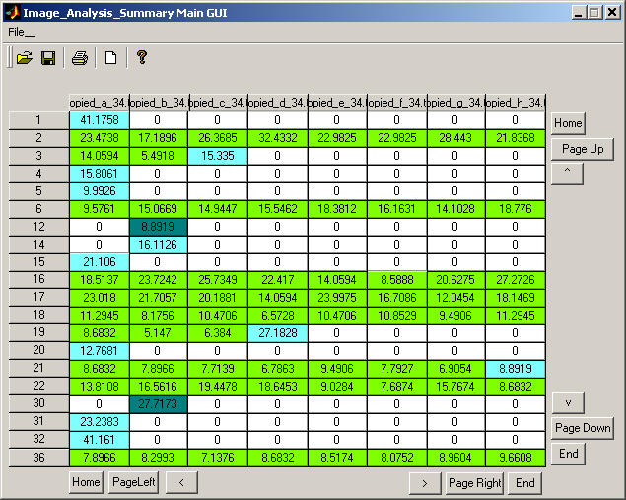 Figure 12

4. Display options

ROI settings and filtering
Use the ‘>>’ button on the stackBrowserControl Main GUI to expand the window.
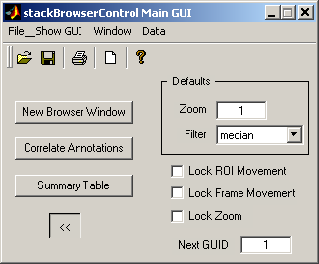 Figure 13
- Zoom indicates the zoom factor with which a new StackBrowser Main GUI presents the ROI in the primary. The default is median.
- The pull-down menu at Filter allows selection of the default filter type that is used when an image stack is opened in a new StackBrowser Main GUI.
- Lock ROI Movement. Check box to link the movements of ROIs in all StackBrowser Main GUIs. This function is very useful (e.g. when image stacks are registered) to explore similar parts of the images with zoomed-in ROIs.
- Lock Frame Movement. Check box to link frame changes in all StackBrowser Main GUIs. This function is very useful for ROIs with a very high zoom, e.g. when selecting for brightness in the photometry program (see below).
- Lock Zoom. Check box to use the same zoom-factor in all StackBrowser Main GUIs.
- Next GUID. This number indicates the correlationID that will be used for the next annotation. The number can be modified by the user. Be aware that this can cause collisions (e.g. two identical correlationIDs in the same stackbrowser; autoIDs will always be different though)!

Display options
Select Show GUI, → stackBrowserDisplayOptions on the menu bar of the stackBrowserControl Main GUI.
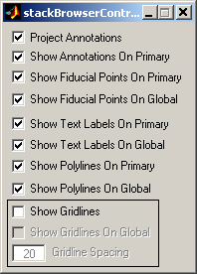 Figure 14
By default boxes are checked as in the example above.
- Project Annotations. Check box to project the annotations on the the primary. When unchecked only annotations that are in the current frame will be displayed.
- Show Annotations On Primary. Check box to display annotation lines. Temporarily unchecking this box can be helpful to reveal the underlaying structures.
- Show Fiducial Points On Primary/Global. Check box to display fiducial points.
- Show Text Labels On Primary/Global. Check box to display the text labels belonging to the annotations.
- Show Polylines On Primary/Global. Check box to display the polylines.
- Show Gridlines. Check to display gridlines on the primary. When the box is checked the Show Gridlines On Global box can also be checked. The Gridline Spacing (in pixels) can be modified as well. This function is helpful during correlation procedures (e.g. to judge whether certain structures in different image stacks are similar positions, see example below).
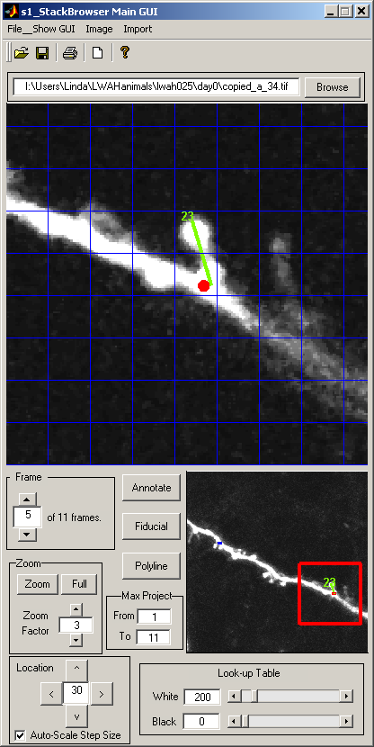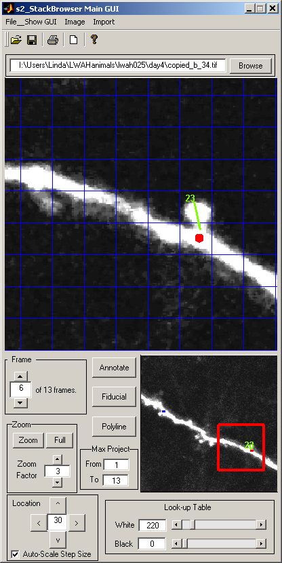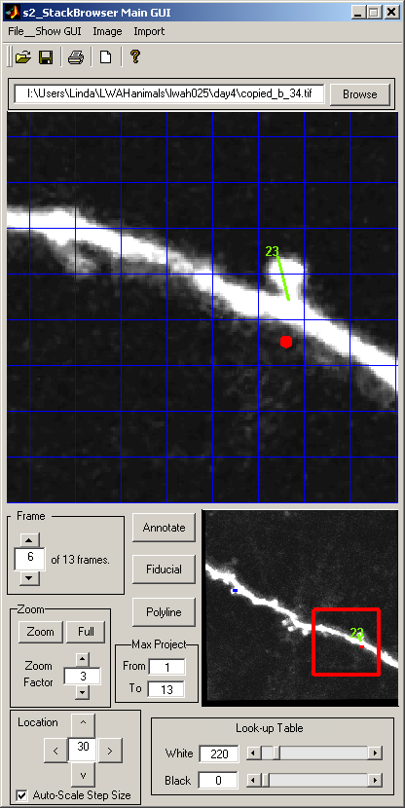
Figure 15. Examples of image registration and use of the gridlines for alignment. Left: the original (‘Old’) image; Middle: the unregistered second (‘New’) image; Right: the registered ‘New’ image. Note, after registration the fiducial points are left at their original position. After the image is transformed annotation 23 (at Right) starts from the exact same position compared to the original image. This can be judged by the gridlines.

Tile stackbrowsers
Figure 16
Use Window, → Tile to tile the stackbrowsers in the form of a stack.

Stackbrowser options
Select Show GUI, → StackBrowserOptions on the stackBrowser Control Main GUI
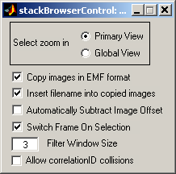 Figure 17
Select zoom in. Check either Primary View or Global View to indicate in which window the user will be able to select an ROI.
Copy images in EMF format. Check to in order to copy images in a compatable format for e.g. vector-based programs such as Adobe Illustrator. This will separate the annotations from the image, so they can be seperately modified in these programs.
Insert filename into copied images. Check box to insert the filename of the imagestack in the copy. This is helpful when images are copied into spreadsheets for reference.
Automatically Subtract Image Offset. Check box to automatically subtract background signal in newly opened imagestacks.
Switch Frame On Selection. Check box to automatically move to the frame in which the annotation is present that gets selected.
Filter Window Size. The number in the box indicates the size of the median filter. Default is 3, but can be changed depending on the noise in the images.
Allow correlationID collisions. Check to allow identical correlationIDs to be present in the same stackbrowser during and after a correlation procedure. If unchecked the program will warn the user if there is an attempt to correlate an annotation that will lead to a collision of correlationIDs in that stackbrowser. A menu will appear and the user gets three options to solve the problem:
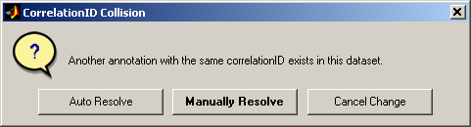 Figure 18
Auto Resolve. The program will accept the current correlation attempt and change the pre-existing identical annotation to the new GUID number.
Manually Resolve. The program will accept the current correlation attempt and leave the pre-existing identical annotation unchanged. Note, this will cause a collision of correlationIDs! The user has to manually change the correlationID of one of them to resolve the problem.
Cancel Change. The program will not accept the current correlation attempt.
5. Measuring pixel intensities

Figure 19
Select Show GUI, → photometry on the menu bar of the StackBrowser Main GUI in which the measurements will be performed.
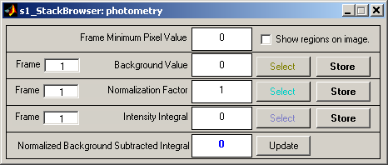 Figure 20
- In general, the select buttons allow the drawing of a polygon on the primary. Each left mouse click sets the endpoint of a line segment in the polygon. The polygon can be closed by a right mouse click. The polygon can subsequently be moved by dragging it with the mouse.
- Background Value. Used to select a background area. The value in the box is the average value of the pixels contained within the polygon.
- Normalization Factor. Used to select an area that will be used for normalization of the measurements. The number in the box is the average value of the pixels contained within the polygon.
- Intensity Integral. Used to select the area of interest of which the intensity integral will be measured, corrected for background and normalized. The number in the box is the integrated value of the pixels contained within the polygon.
- Normalized Background Subtracted Integral. Indicates the final outcome of the measurement. The Update button can be used to recalculate the value, in case on of the other measurements has changed.
- The Store buttons will store the indicated values in the data set.
- Frame. Indicates in which frame the measurements are performed.
- Frame Minimun Pixel Value. Indicates the lowest pixel value in the current frame.
- Show Regions on image. Check to display the polygons. Uncheck when they disturb other measurements or annotations.

The automated annotation intensity measurement option is currently not operational. The StackBrowserFeatureRecognitionOptions under Show GUI in the menu bar of the stackBrowser Control Main GUI, can therefore be ignored.

